**Case Study and Experiments – Devops Process Flow**



**Ex. No: 8 Date:**

**Aim:**

*Activity:*Indian railways minister Shri. Ashwini Vaishnav is going to launch an ultra-high featured IRCTC website and application. Describe the Devops workflow and involvements in Devops tools on IRCTC Project.

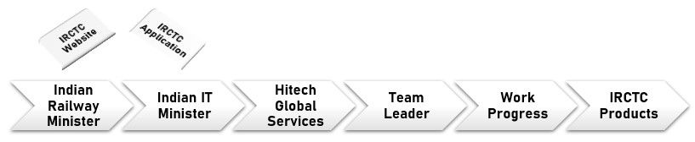

**Configuration Details:**

|  |  |  |
| --- | --- | --- |
| **1.** | **Problem** |  |
| **2.** | **Process** |  |
| **3.** | **Tools** |  |

**Devops Process Diagram:**

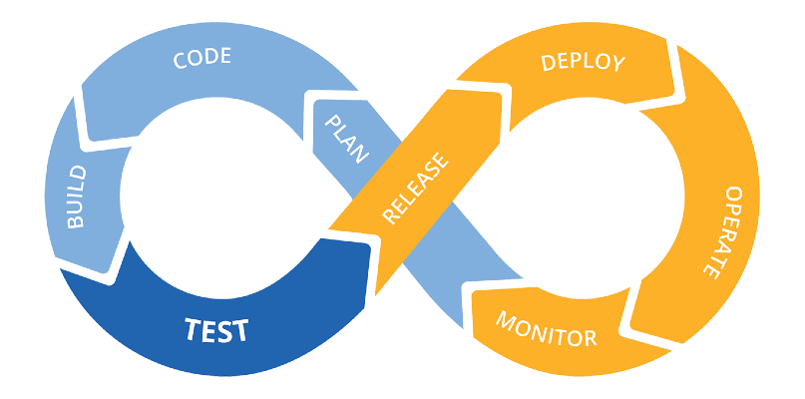

**DevOps Process Stages:**

**Planning:**

This is the very first stage of DevOps. Here we will plan the entire process that we are going to implement in the project which was given by HITECH GLOBAL SERVICE. The team got this project from the Indian IT minister. The Indian IT minister got this project from the Indian Railway Minister who wanted to update the IRCTC websites and application by adding some more advanced features. So, we can add a new feature like providing food for the passengers based on their tickets. It means that, when the passengers book the tickets, before the completion of booking, there we can add a food menu. In that, they can select whatever food they want and it will be printed in their tickets also. So that, they can even get their food just by showing their tickets. This helps the persons who are working in train to prepare the required food for passengers in advance as per the passenger’s count.

**Coding:**

Coding is the second stage of DevOps. Here we will do coding for the feature that we need to implement. The coding will be done separately for each and every page by using HTML, JavaScript and some other programming languages to implement the feature. In DevOps, Coding plays an important role because the website which we are going to create is fully based on the coding process only. The teams members will split themselves into smaller teams like one person will work on the Login page, one will do coding for the home page, and one will do coding for the working features, etc..

**Built:**

Built is the next stage in DevOps. Here we will join all the coding works done by our coders in the previous stage. In other words, building an application or website or feature is completely done in this stage. Here all the coding will be combined together to form a complete application or feature.

**Testing:**

Next stage of the DevOps is Testing. In this stage, we will test what we built. It will be tested if it works well so we will get to know where exactly the code is having bugs. And if there is any mistakes found, it will be returned or else the application will move to the next stage.

**Release:**

In this release stage, all the units of the codes are integrated. That means in this step we will be creating a connection between the development team and the operation team to implement continuous integration and continuous deployment. Here after testing, if the feature works well and good, it will be released for use.

**Deploy:**

The next stage of the DevOps is Deploy. In this stage, the code is deployed on the client’s environment. The client will test the application. After using the application he will approve the project and will give it to the Indian IT minister. Then the IT minister will give it to the Indian Railway Minister.

**Operate:**

In this stage, the full work is done by the operation team. Operations are performed on the code if required. And moreover, in DevOps, the operation team can easily communicate with the development team. This add extra benefit to the DevOps.

**Monitor:**

This is the final stage in DevOps. Monitoring of the application is done over here in the client’s environment. That is in this stage, we will monitor the working condition of the feature.

**Devops Tools:**

Tools that are used to create the new feature in IRCTC website are,

**Built:**

In this process, we use Gradle, maven tools to combine the coding into one complete application or feature.

**Testing:**

In this process, we use Selenium, PY test tools to test the feature that we are going to implement.

**Release:**

In this process, we use Jenkins.

**Deploy:**

In this process, we use AWS, Docker tools.

**Operate:**

In this process, we use Kubernetes, open shift tools.

**Monitor:**

In this process, we use Nagios, elastic stack tools.

**Inference:**

**Result:**